**Assessment 1** (Database file attached in the end)

**Q1) Source Code:**

import **java**.**sql**.*;

public class **App** {

    static ResultSet rs = null;

    static Statement stmt = null;

    static Connection con = null;

    public static void **main**(String[] args) throws Exception {

        try {

*// Register JDBC driver*

            Class.**forName**("com.mysql.cj.jdbc.Driver");

*// Open a connection*

            con = DriverManager.**getConnection**(

                    "jdbc:mysql://localhost:3306/mindtree_1", "root", "akshit@2000");

            stmt = con.**createStatement**();

*// Executing a query*

**String** query1 = "select * from Mobile where CAMERA = (select max(CAMERA) from Mobile);";

**String** query2 = "select * from Mobile where PRICE = (select min(PRICE) from Mobile);";

**System**.out.**println**("---- ANSWER : 1 ----");

            rs = stmt.**executeQuery**(query1);

**System**.out.**println**("Attributes of mobile with highest camera:");

**displayResult**(rs);

            rs = stmt.**executeQuery**(query2);

**System**.out.**println**("Attributes of mobile with lowest price:");

**displayResult**(rs);

                con.**close**();

        } catch (**Exception** e) {

**System**.out.**println**(e);

        }

    }

    public static void **displayResult**(**ResultSet** rs){

        try {

            while (rs.**next**())

**System**.out.**println**(rs.**getString**(1) + "  " + rs.**getString**(2) + "  " + rs.**getInt**(3) + "  " + rs.**getInt**(4) + "  " + rs.**getInt**(5) + "  " + rs.**getFloat**(6));

        } catch (**Exception** e) {

**System**.out.**println**(e);

        }

    }

}

**Output:**

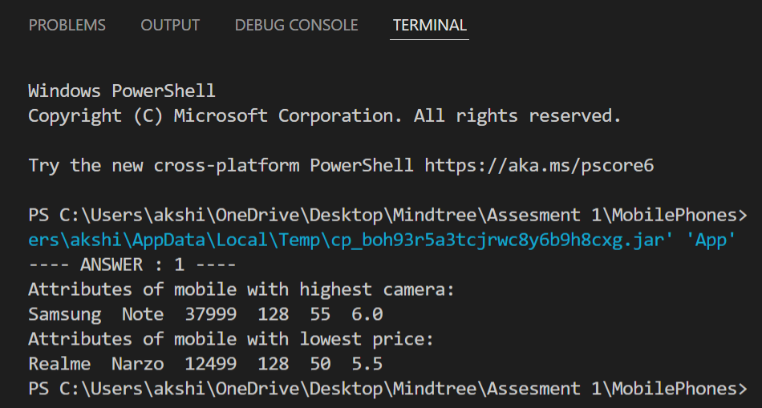

**Q2) Source Code:**

import **java**.**sql**.*;

public class **App** {

    static ResultSet rs = null;

    static Statement stmt = null;

    static **Connection** con = null;

    public static void **main**(**String**[] args) throws **Exception** {

        try {

*// Register JDBC driver*

**Class**.**forName**("com.mysql.cj.jdbc.Driver");

*// Open a connection*

            con = **DriverManager**.**getConnection**(

                    "jdbc:mysql://localhost:3306/mindtree_1", "root", "akshit@2000");

            stmt = con.**createStatement**();

*// Executing a query*

**String** query1 = "SELECT NAME, BRAND FROM Mobile WHERE DISPLAY = (SELECT MAX(DISPLAY) FROM Mobile);";

**System**.out.**println**("---- ANSWER : 2 ----");

            rs = stmt.**executeQuery**(query1);

**System**.out.**println**("Name and brand of the mobile with the biggest screen size:");

            while(rs.**next**()){

**System**.out.**println**(rs.**getString**(1) + "  " + rs.**getString**(2));

            }

                con.**close**();

        } catch (**Exception** e) {

**System**.out.**println**(e);

        }

    }

}

**Output:**

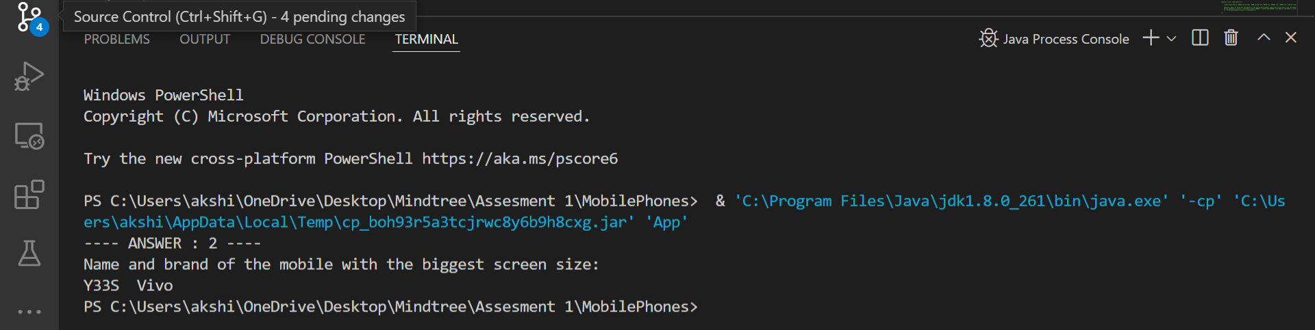

**Q3) Source Code:**

import **java**.**sql**.*;

public class **App** {

    static ResultSet rs = null;

    static Statement stmt = null;

    static **Connection** con = null;

    public static void **main**(**String**[] args) throws **Exception** {

        try {

*// Register JDBC driver*

**Class**.**forName**("com.mysql.cj.jdbc.Driver");

*// Open a connection*

            con = **DriverManager**.**getConnection**(

                    "jdbc:mysql://localhost:3306/mindtree_1", "root", "akshit@2000");

            stmt = con.**createStatement**();

*// Executing a query*

**String** query1 = "SELECT CAMERA, PRICE from Mobile where NAME = 'IPHONE 13';";

**System**.out.**println**("---- ANSWER : 3 ----");

            rs = stmt.**executeQuery**(query1);

**System**.out.**println**("Camera and Price of the mobile with name 'IPHONE 13'");

            while(rs.**next**()){

**System**.out.**println**(rs.**getInt**(1) + "  " + rs.**getInt**(2));

            }

                con.**close**();

        } catch (**Exception** e) {

**System**.out.**println**(e);

        }

    }

}

**Output:**

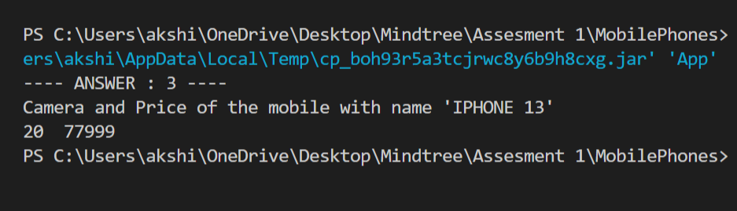

**Q4) Source Code:**

import **java**.**sql**.*;

public class **App** {

    static **ResultSet** rs = null;

    static **Statement** stmt = null;

    static **Connection** con = null;

    public static void **main**(**String**[] args) throws **Exception** {

        try {

*// Register JDBC driver*

**Class**.**forName**("com.mysql.cj.jdbc.Driver");

*// Open a connection*

            con = **DriverManager**.**getConnection**(

                    "jdbc:mysql://localhost:3306/mindtree_1", "root", "akshit@2000");

            stmt = con.**createStatement**();

*// Executing a query*

**String** query1 = "SELECT NAME, BRAND FROM Mobile WHERE price >=10000 AND price<=20000 AND camera >=30 AND camera <=50; ";

**System**.out.**println**("---- ANSWER : 4 ----");

            rs = stmt.**executeQuery**(query1);

**System**.out.**println**("Names and brands of all the phones with price from 10000 to 20000 and camera from 30-50 MP from the mobile table:");

            while(rs.**next**()){

**System**.out.**println**(rs.**getString**(1) + "  " + rs.**getString**(2));

            }

                con.**close**();

        } catch (**Exception** e) {

**System**.out.**println**(e);

        }

    }

}

**Output:**

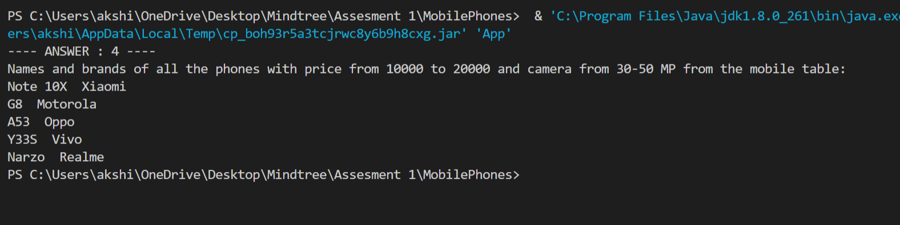

**Database File:**

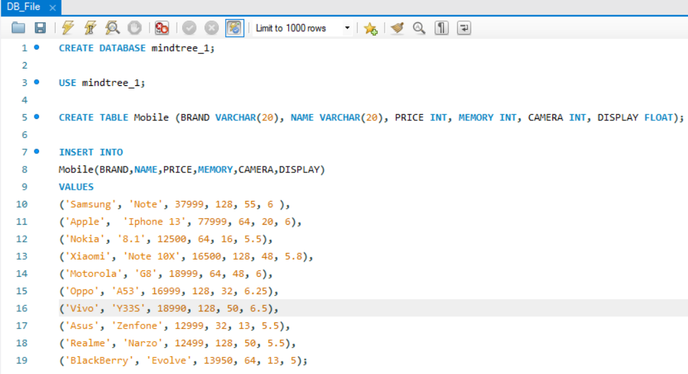

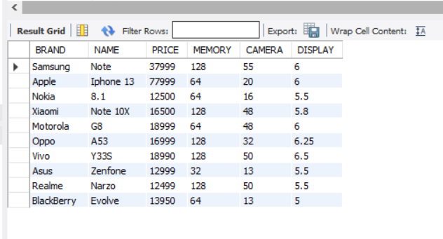**Mobile Table:**